**Team composition:** Olariu Maria-Ecaterina

Peterca Adrian

Vlad Theodor

**Type of game you intend to implement:**

Horror maze

**Core gameplay:**

You are someone who wakes up surrounded by walls. How you got here, who brought you here or what is this place is unknown. What you know for sure is that you are not alone. It’s dark and cold, so you must find a way out of this maze.  
 Using a 2D perspective, the player must find his way out of a dark maze. In the maze, there are certain obstacles that must be dealt with: traps, hidden walls, rotating areas, maybe even monsters. Using a minimap (which at first is pitch black), the player can orient themselves if they choose so (hidden in the maze there are certain points that can be switched to bring a little light). Besides the obstacles and the need to escape, the player must also collect some sort of objects (for instance, thesis papers for the Bachelor’s degree) and then make his way out of the maze.

The core gameplay consists of maze solving, exploring and survival, using an adequate atmosphere for a horror setting.

**Similar concepts and reference ideas:**

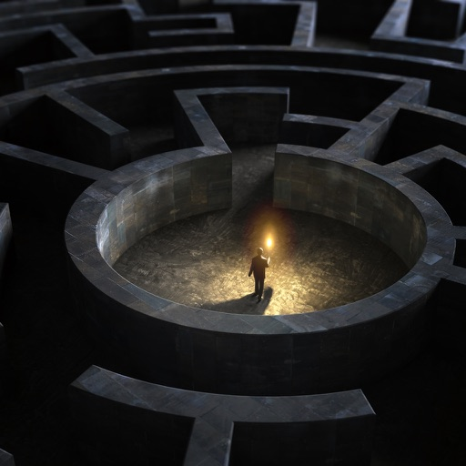

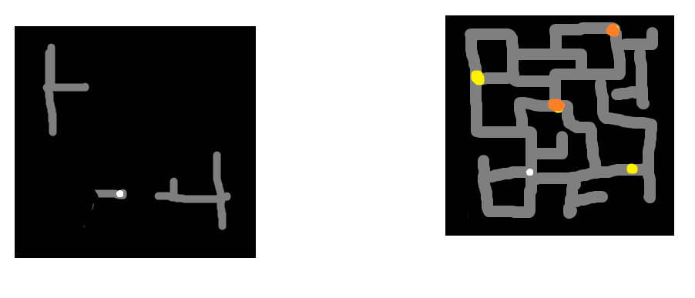

(it’s easier to explain in person)